

`

TOM Integration
Interface Specification
On
Base Product Data Update
From IDS to IKB

[S036]

(This Interface also covers the requirements for logical Interface, S036.5 (Display Group) from CRDB to IKB)

Project BEN Code: | W60416
Author: | Nitin Singhai
Date: | 18/01/2007
Version: | 0.5
Status: | Draft
Modified By: | Nitin Singhai
Reviewed By: | Adrian Hinks (initial review 16/02/07)

Change Record

Author | Date | Version | Change Reference, description
Nitin Singhai | 18-01-2007 | 0.1D | Draft
Nitin Singhai | 14-02-2007 | 0.2D | Draft
Adrian Hinks | 16-02-2007 | 0.3D | Changes resulting from review
Nitin Singhai | 06-03-2007 | 0.4D | Changes resulting from review
Nitin Singhai | 21-05-2007 | 0.5D | Incorporated Display Group Requirements. Updated specs to get data for SKU from a common Product table instead of the common form.
Nitin Singhai | 07-06-2007 | 0.6D | Updated the folder structure details in Section 2.2 and 2.3.
Nitin Singhai | 20-Jun-2007 | 0.7D | Target Schema updated as per the latest JDA Holding Table.
Nitin Singhai | 29-Jun-2007 | 1.0 | Updated the SSIS package Name in section 5.7

Reviewers

Name | Date | Version | Position
Andrew Barker
Adrian Hinks | 16-02-2007 | 0.2D | Engagement Architect

At least one reviewer is required.

Sign-Off

By signing this form, I understand and agree with the contents of this document.

Business Owner/Customer
Position
Signature | <Physical signature or via email approval>
Date | dd/mm/yyyy (<version signed off>)

Distribution List

Name | Date of Issue | Version
Andrew Barker
John Cowper
Jon Braggs
David Onyett
Venkateswara Rao

Document Source
DocShare: UK IT/TOM Integration/Shared Documents

Related Documents

A complete interface specification requires three documents- an Interface Specification, an Information Architecture Context diagram, and a Mapping spreadsheet. This section identifies these documents plus other documents as appropriate.

Information Architecture Context diagram
S036 Information Context Diagram - Product Information Update.vsd

Mapping spreadsheet
S036- Product Information Update (IDS - CRDB to IKB) Mappings.xls

Other Reference Documents
Tesco - Product Data Interface & Dimension Changes v1 4.doc
Table of Contents
1 Introduction 6
1.1 Purpose of Document 6
1.2 Background 6
1.3 Scope 6
2 Description and Requirements for the End-to-End Interface 7
2.1 Description of the End-to-End Interface 7
2.2 Architecture 8
2.3 Requirements of the End-to-End Interface 8
2.4 Non-Functional Requirements of the End-to-End Interface 9
3 Processing Required in the Extract Stage of the Interface (IDS to SSIS) 10
3.1 Scope 10
3.2 Source Message Schema 10
3.3 Message Transport Details 10
4 Processing Required in the Extract Stage of the Interface (CRDB to SSIS) 11
4.1 Scope 11
4.2 Source Message Schema 11
4.3 Message Transport Details 12
5 Processing Required in the SSIS Stage of the Interface 13
5.1 Scope 13
5.2 Package Overview 13
5.3 Data Validation 13
5.4 Filtering 13
5.5 Mapping 13
5.6 Target Message Schema 13
5.7 Message Transport Details 15
Naming and Configuration 15
5.8 Environment and Security Context 16
5.9 Non-Functional Requirements 16
6 Processing required in the <third stage of the interface> 17
6.1 Scope 17
6.2 Data Validation 17
6.3 Filtering 17
6.4 Mapping 17
6.5 Target Message Schema 17
6.6 Message Transport Details 17
6.7 Naming and Configuration 17
6.8 Environment and Security Context 17
6.9 Non-Functional Requirements 17
7 Testing Deliverables 18
8 Deployment 19
9 Assumptions and Outstanding Issues 20
9.1 Assumptions 20
9.2 Outstanding Issues 20
Appendix A Volumes 21
Appendix B Glossary 22
Appendix C Document Control 23

Introduction

Purpose of Document
The purpose of this document is to describe the interfacing requirements w.r.t Product reference data between the IDS to IKB. The document is of a sufficiently technical nature to allow a developer to build an actual interface. Additionally the document contains detail that might sit logically within a Technical System Design (TSD) document, but is contained here for expediency. There is therefore no associated TSD for this interface.

This interface is for US and Turkey implementation.

Background
As part of Tesco Operating Model program, there is requirement to bridge the functionalities of enterprise applications including IDS, CRDB and IKB. To achieve this functionality, high level process flow architecture has been designed and approved by Tesco’s Enterprise Architecture team. As part of this process flow architecture there is a set of interfaces that has been identified to be developed to transfer Product reference data from IDS and CRDB into IKB.
The Base Product information, Supplier Information and Merchandise Hierarchy is initially loaded from ORMS to Integration Data Store (IDS). Most of the systems within SRD require the Base Product information and hence the data is loaded in TIDS before actually delivering it to the systems to maintain consistency of the data provided by the Integration Layer. The interface which gives the data to TIDS from IDS is S100. This interface will be scheduled after S100 interface has run successfully.
The Display Group Information is maintained in CRDB system. This Information is extracted nightly from CRDB in the form of file.

Scope
The Interface Specification covers:

- audit requirements across the interface
- security requirements across the interface
- timing/frequency requirements or constraints
- support requirements
- archiving
- the data format to be used for the interface at each stage (e.g. xml messages)
- the normal processing required at each stage
- recovery from failure required at each stage
- volumes.

Note that it is Tesco strategy to avoid placing any business logic in integration layer processing.

Description and Requirements for the End-to-End Interface

Description of the End-to-End Interface
The interface is an extract of Product Reference Data from IDS Temporary Holding Table and Display Group Information from CRDB (flat file) and uploads into the IKB Product Holding Table using SSIS.
The Interface has two dependencies to check before it executes and inserts data into Target holding Table.

These dependencies are:
- To Check the CRDB outfile for Display Group. If file is present, continue to step 2 else hold for sometime (TBD) and retry again.
- To Compare the S036 Interface last run timestamp with S100 timestamp. If S036 Interface timestamp is greater than S100 timestamp (that means S036 has already run previously with the latest data) then hold the Interface for sometime (TBD) until S100 updates the timestamp, else proceed with the S036 Interface execution.

The Product Data resides in a common Product Holding Table (SKUItem_Staging). Apart from Product Data, this Interface requires additional data i.e. Supplier Name and Merchandise Hierarchy for each Product. This data is fetched via common forms from IDS. A nightly job extracts data from Product temporary table (full upload) and gets the corresponding Supplier data and Merchandise Hierarchy data via common form services cf_getdivisionhierarchy_usp, cf_getsupplierhierarchy_usp. For each Product ID fetched from IKB, a corresponding Display Group name is fetched from CRDB (Data resides in the form of flat file in CRDB). The CRDB source flat file for Display Group will be placed in the CRDB OUTBOX of CRDB system’s folder, which in turn is directly accessible by the Integration Layer.

The Upload is a full upload in nature.

Once the upload is done, the Interface should write the successful completion of Interface run in TIDS Control Table (SKUItem_Staging).

Once the CRDB file is read, the Integration layer will move the file to ARCHIVE directory in the CRDB \ ARCHIVE application folder.

Cleaning up of IKB Holding Table is not in scope of IL i.e. deleting records from IKB Holding Table will be handled by target IKB system.

Architecture
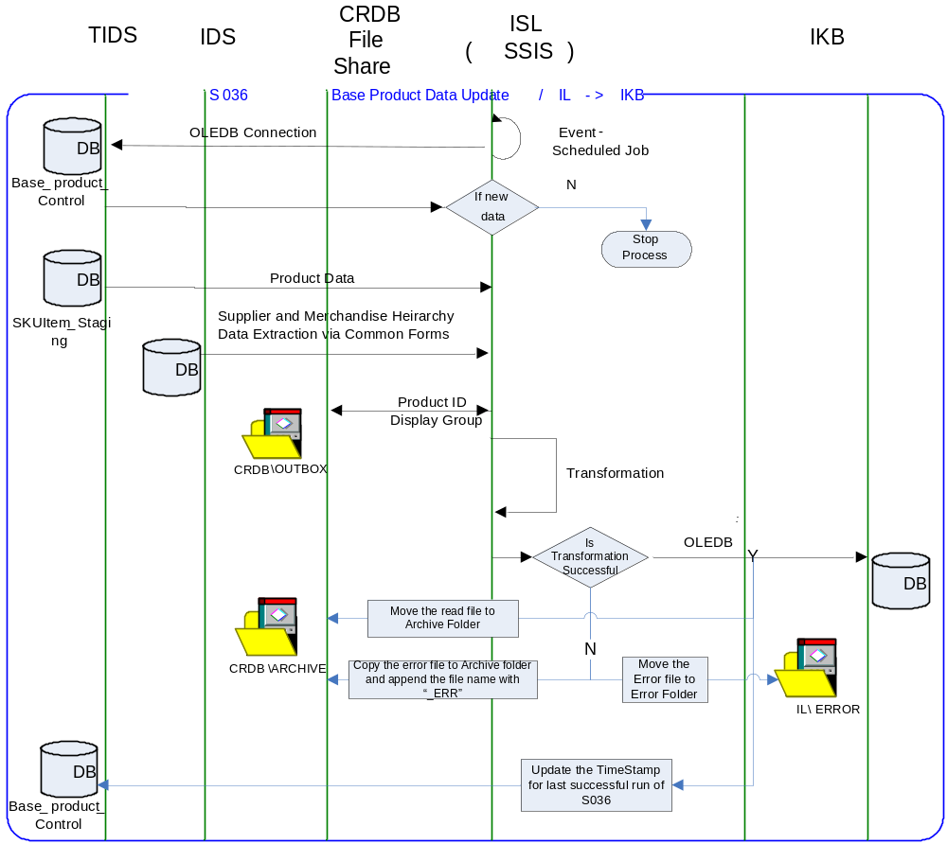

Requirements of the End-to-End Interface
The interface will run once a day, on scheduled basis, and consists of a SQL Server Integration Services package that extracts data from the IDS and CRDB, and formats it into the target Holding Table format.

The interface is meant to run nightly at a pre-configured time 5 days a week (Tuesday to Saturday), which on completion is expected to upload the Product data in a Product Holding Table in IKB.

The interface will make use of the audit and traceability components that are being developed as part of the Operational Framework stream. These components will be pluggable, and will be useable from BizTalk, RTI, and SSIS. At the time of writing (2007-01-18) the components are in design. Although not ready for use, they are included on the Information Architecture Context diagram where their functionality is required. Developers should put a ‘placeholder’ in their code / configurations as appropriate.

Non-Functional Requirements of the End-to-End Interface

Audit Requirements | The interface will use the components provided by the Operational Framework to satisfy audit requirements.
Security Requirements | The interface executes within a secure private domain. There are no additional security considerations required.
Timing/Cut-off Constraints | To be finalised.
Performance Requirements | The interface should be capable of extracting data from IDS Temporary Table and CRDB flat file, delivering the resulting data to IKB Product Holding Table before the identified cut-off time. The interface should run on scheduled batch basis.
Reliability and Availability Requirements | The interface-run should be atomic in nature. Appropriate mechanisms should be in place to raise/alert appropriate parties.
Scalability Requirements | No Scalability requirement. The requirement is to deliver a single extract. It is anticipated that the volume of data transferred will continue to remain within the capability provided by this implementation.
Operational Support Requirements | The scheduled start of the extract job and/or the completion of the target table update should be defined as IMOF events.
Likelihood of Change Requirements | There is no such requirement
Cultural/Global Consideration Requirements | Although multi-byte character set support is not required for US or Turkey, the interface will support multi-byte character sets through integration.
Legal Requirements | N/A
Compliance To Standards Requirements | No compliance exceptions.

Processing Required in the Extract Stage of the Interface (IDS to SSIS)

Scope
This section describes the data sources required by this interface and the services used to access the data.

Source Message Schema
The Product data for this interface resides in the TIDS Base Product Staging Table SKUItem_Staging. For each Product ID, corresponding Supplier Name and Merchandise Hierarchy are fetched via common forms. The services are exposed as stored procedures that fetch data from Base Product Staging Table SKUItem_Staging in TIDS and from common forms.

TIDS Staging Table Name: SKUItem_Staging

Message Transport Details

Feature | Specification | Additional Information
Source System Name | IDS
Source Platform / OS | Windows 2003 Server
Source Physical Location | SQL SERVER 2005
Source Underlying Data Storage Technology | RDBMS
Target System Name | SSIS
Target Platform / OS | Windows 2003 Server
Target Physical Location
Target Underlying Data Storage Technology | RDBMS
Transfer Function | HTTP (Put/Post) □  HTTPS (Put/Post) □  Message Queue □  FTP □  File Drop(Windows) □  (XCOM) □  RDBMS ☑  Common Forms ☑
Data Format. | XML □  Delimited □  Positional □  RDBMS ☑
Decryption/Encryption | No
Decompression/Compression | No
Transmission Mode | Synchronous □  Asynchronous ☑  Bulk Data □
Real-time/Scheduled Batch | Not yet decided
Archiving | There is no requirement to archive the messages.
Logging | Log via the Operational Framework.
Error Handling | Not yet decided  Processing should prevent sending of duplicate messages, unless this occurs during recovery from failure.

Processing Required in the Extract Stage of the Interface (CRDB to SSIS)

Scope
This section describes the data sources required by this interface and the services used to access the data.

Source Message Schema
Display Group Information is fetched from CRDB file for each Product ID available in SSIS memory. (Product Information is available in IL SSIS memory, from previous Step 3).
Note: If a Display Group is not found in the file for a product, pass the value for Display Group as null.

File Name: Business date_CRDB_S036_000000_System creation date_System creation time.txt (TBC)
BusinessDate format = yyyymmdd
System Creation Date format = yyyymmdd
System Creation Time format = hhmmss

Field Name | Type | Length | Description
Header Record
Record Type | CHAR | 2 | Set to '00' for the header record.
Date/Time File Created | CHAR | 14 | File Creation Date format “YYYYMMDDhhmmss”
Sequence number | CHAR | 6 | Set to '000000'
Date | CHAR | 8 | Business date
File Id | CHAR | 3 | Set to '000'
Detail Record
Record Type | CHAR | 2 | Set to '01' for the Detail record.
Product ID | Varchar | 9 | Product ID
Display Group ID | Varchar | 3 | Display Group ID
Display Group Name | Varchar | 30 | Display Group Name
Trailer Record
Record Type | CHAR | 2 | Set to '99' for the footer records
Record count | Integer | 10 | This will count data records only. The number will contain leading zeros.

Message Transport Details
Feature | Specification | Additional Information
Source System Name | CRDB
Source Platform / OS | Windows 2003 Server
Source Physical Location | CRDB File Share
Source Underlying Data Storage Technology
Target System Name | SSIS
Target Platform / OS | Windows 2003 Server
Target Physical Location
Target Underlying Data Storage Technology | RDBMS
Transfer Function | HTTP (Put/Post) □  HTTPS (Put/Post) □  Message Queue □  FTP □  File Drop(Windows) ☑  (XCOM) □  RDBMS □
Data Format. | XML □  Delimited □  Positional ☑  RDBMS □
Decryption/Encryption | No
Decompression/Compression | No
Transmission Mode | Synchronous □  Asynchronous ☑  Bulk Data □
Real-time/Scheduled Batch | Not yet decided
Archiving | IL Should move the CRDB file into a Shared folder after the successful read of the file. (TBC)
Logging | Log via the Operational Framework.
Error Handling | Not yet decided  Processing should prevent sending of duplicate messages, unless this occurs during recovery from failure.

Processing Required in the SSIS Stage of the Interface

Scope
This section describes the discreet steps within the SSIS package to extract and format data. The target schema is included in this section.

Package Overview
SSIS extracts the product reference data from IDS using Common Forms, nightly at predefined time, 5 days a week. In turn, the data is inserted into an Intermediate table at IKB which is the Product Holding Table csg_product_data.

Data Validation
N/A

Filtering
There is no filtering requirement.

Mapping
Please refer Page iii for Mapping Details.

Target Message Schema
Holding Table Field Name | Type | Length | Description
IsProcessed | int |  | Field used by JDA for Internal purpose. Pass null from integration.
DateTime | datetime |  | This field will be populated with the current date/time that records are added. This will be done as part of the process that adds data to this table. This field will be used to sort the records to ensure that they are processed in the correct order.
Product_description | varchar | 32 | Product Name
UPC | varchar | 13 | UPC Code
Product_ID | varchar | 20 | Tesco Product Number
EAN_Code | varchar | 13 | EAN Code
Department | varchar | 30 | Department Number
Display_Group | varchar | 30 | Display Group of the Product
Manufacturer | varchar | 30 | Manufacturer Name
Supplier | varchar | 40 | Supplier Name
Case_Pack_Size | int |  | CaseTotal Number
Height | real |  | Height of Product
Width | real |  | Width of Product
Depth | real |  | Depth of the Product
Tray_Height | real |  | Tray Height of the Product
Tray_Width | real |  | Tray Width of the Product
Tray_Depth | real |  | Tray Depth of the Product
Tray_Pack_Size | int |  | Tray Total Number
Colour | varchar | 30 | Color of the Product
Product_launch_date | datetime |  | Product Launch date
Product_end_date | datetime |  | Product End date
SEL_type | varchar | 30 | Shelf Edge Label Type
Good_better_best | varchar | 30 | Product Characteristics as Good Better or Best
Warehouse_indicator | varchar | 30 | Indicator
Commercial_unit_height | float |  | Used for any product height change.
Commercial_unit_width | float |  | Used for any product width change.
Commercial_unit_depth | float |  | Used for any product depth change.
Commercial_tray_height | float |  | Used for any product tray height change.
Commercial_tray_width | float |  | Used for any product tray width change.
Commercial_tray_depth | float |  | Used for any product tray depth change.
Dummy_product | int |  | Indicator to Indicate whether a Product is a dummy Product or Authorized.
Authorised | int |  | Indicator to Indicate whether a Product is a dummy Product or Authorized.
Diamond_line | Char | 1 | Product Quality Attribute
Organic | int |  | Product Quality Attribute
Finest | int |  | Product Quality Attribute
Value | int |  | Product Quality Attribute
Future_dimension_present | int |  | Internal use for JDA to identify any product Dimension changes.
Price | Float |  | Price of the Product
Case_cost | Float |  | This is a derived field. (Unit Cost X Case Pack Size)
Unit_cost | Float |  | Unit Cost of the Product
Subclass_code | varchar | 30 | Subclass ID
Subclass_desc | varchar | 30 | Subclass Name
Traypack_indicator | varchar | 30 | Indicator. If Tray Pack can break to adjust on shelf.
Seasonal | varchar | 30 | Attribute of a Product.
Phasing | varchar | 30 | Attribute of a Product.
Brand | varchar | 30 | TescoBrand of the Product
Buyer | varchar | 30 | Buyer
Tray_units_high | int |  | Number of Units high in a Tray
Tray_units_wide | int |  | Number of Units Wide in a Tray
Tray_units_deep | int |  | Number of Units Deep in a Tray

Message Transport Details
For messages destined for IKB system, the following applies.

Feature | Specification | Additional Information
Source System Name | SSIS
Source Platform / OS | SQL Server 2005
Source Physical Location
Source Underlying Data Storage Technology
Target System Name | IKB
Target Platform / OS | SQL Server
Target Physical Location
Target Underlying Data Storage Technology
Transfer Function | HTTP (Put/Post □  HTTPS (Put/Post) □  Message Queue □  FTP □  File Drop (Windows) □  (XCOM) □  RTI file Adapter □  SSIS ☑
Data Format | XML □  Delimited □  Positional □  RDBMS ☑
Decryption/Encryption | No
Decompression/Compression | No
Transmission Mode | Synchronous □  Asynchronous ☑  Bulk Data □
Real-time/Scheduled Batch | RDBMS extract
Archiving | There is no archiving requirement
Logging  Should logs be kept of all actions? For how long should these be stored? | Logging should occur, such that the message can be recreated if necessary.
Error Handling | Not yet decided  Processing should prevent sending of duplicate messages, unless this occurs during recovery from failure.

Naming and Configuration
SSIS
Package Name: TOM.S036.IDS_CRDBtoIKB.ProductInformationUpdate.dtsx
Name | S036_IDS-CRDBtoIKB_usp
<Placeholder for other package components/steps>
<Placeholder for other package components/steps>

Environment and Security Context
Account details will be included here once we have visibility of the environments.

Non-Functional Requirements
On successful delivery of the data to the target system, the audit log should be updated via the Operational Framework pipeline component or adapter (to be determined).

In the event of a failure of transformation of data should be written to the failed log database, and an alert should be raised.

Processing required in the <third stage of the interface>

Scope
There is no intermediate staging is required for this interface. So this section is not applicable.

Data Validation
Not Required

Filtering
Not Required

Mapping
Not Required

Target Message Schema
Not Required

Message Transport Details
Not Required

Naming and Configuration
Not Required

Environment and Security Context
Not Required

Non-Functional Requirements

Not Required

Testing Deliverables
This section should contain a list of discrete deliverables. The following table is an illustrative template only. The exact deliverables will depend on the technologies employed in the interface.

Deliverable | Description
TBD <stored proc name> | Common Form Stored Procedure
TBD <stored proc name> | Common Form Stored Procedure
TBD <service name> | Common Form Web Service
TBD <SSIS package name> | Package
TBD <RTI configuration file> | Xml configuration file exported from RTI. For testing, this should contain the configuration required to support this interface only.  For production, configuration should be documented under section 7 Deployment.
TBD <script name> | Unit Test Scripts. Scripts should be provided to:  - create databases (including stored procedures).  - populate with the minimum set of test data to satisfy functional requirements  - notes showing how to use scripts and describing the functions tested.
<installer> | Installers as appropriate to the technology being used.

Deployment

Assumptions and Outstanding Issues

Assumptions
ID | Assumption
1 | Interface shall not run until CRDB Display Group file is provided in the CRDB outbox.
2 | There will be only one Product – one Display Group pair in the CRDB flat file.

Outstanding Issues
ID | Issue | To be addressed by
1 | Timings and cut-off constraints need to be defined. Require input from SRD. | Space, Range, Display Solution Architects and Information Architect
2 | Deployment not yet considered | Information Architect
3 | Alert numbers/identifiers are yet to be defined | Information Architect
4 | The design of the IMOF is still being worked and will require retro-fitting to the interface | Information Architect
5 | CRDB Outbox location is not yet defined. | Information Architect
6 | CRDB File Layout and File Name to be decided. | Space, Range, Display Solution Architects and Information Architect

- Volumes
- Glossary

Acronym | Term | Description
EAI | Enterprise Application Integration | The process of meeting the data requirements of applications by providing a message based transport from disparate data sources across all forms of enterprise technology.
EAI Layer | Enterprise Application Integration Layer | Refers to the integration services provided to implement EAI. In contrast to the EIA Layer for data services. See below.
EIA | Enterprise Information Architecture | Creation of a strategic single view of data across the enterprise.
Interface | Interface | Many definitions exist for 'interface'. In general, 'interface' refers to the link between a data source and a data target. And there are properties of the interface in this context. However more specifically 'interface' refers to one end of a data link, hence the terms source interface and target interface, and both the source interface and the target interface will have specific properties of their own.
RMS | Retek Merchandising System | Retek Merchandising System is getting installed for TESCO Merchandising operations in US. This system will governs the Merchandising operations; Receive base Master & Transaction data and from other systems and Provide data to next level of operation system as part of Retail systems chain.
IKB | Intactix Knowledge Base | SQL Server Database provided by JDA Intactix for Space Planning and Floor Planning.
IDS | Information Data Store | A store of data, logically residing in the EIA layer, that provides an authoritative single view of a discrete data component specific to the enterprise. Eg: Product, Store, etc. IDS's reside in the EIA Layer, and are accessed through the EAI Layer.
IMOF | Integration Management Operational Framework | IMOF is a framework which is pluggable to any Biztalk, RTI and SSIS for alerting, exception handling, defining rules, scheduling etc

- Document Control
Change Record

Author | Date | Version | Change Reference, description
Nitin Singhai | 18-Jan-2007 | 0.1 | Draft
Nitin Singhai | 14-Feb-2007 | 0.2 | Draft
Adrian Hinks | 16-Feb-2007 | 0.3 | Changes resulting from review
Nitin Singhai | 06-Mar-2007 | 0.4 | Incorporated Review comments.
Nitin Singhai | 16-May-2007 | 0.5 | Incorporated Display Group Requirements. Updated specs to get data for SKU from a common Product table instead of the common form.
Nitin Singhai | 07-Jun-2007 | 0.6 | Updated the folder structure details in Section 2.2 and 2.3.
Nitin Singhai | 20-Jun-2007 | 0.7 | Updated the Target IKB Field definitions as per the latest JDA Holding Table definition.
Nitin Singhai | 29-Jun-2007 | 1.0 | Updated the SSIS Package Name in Section 5.7

Related Documents

Author | Date | Version | Title

Distribution

Name | Position | Approver/Contributor/Other
Jon Braggs | Enterprise Architect
Andrew Barker | Engagement Architect
David Onyett | Project Lead

